# Unacademy Hackathon - Product Assignment

**CatchUp** - Discover Social Experiences

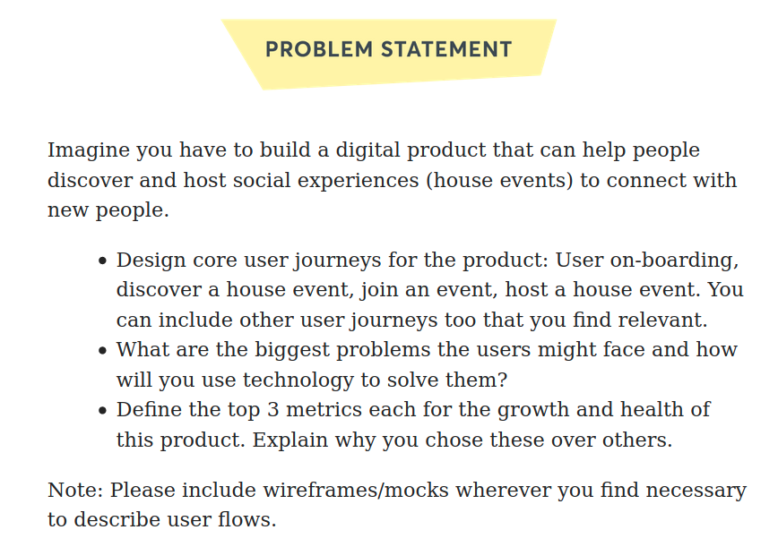

**Problem Definition:-** As per a recent [study](https://edition.cnn.com/2016/06/06/health/losing-friends-mid-twenties/index.html), one’s social circle shrinks after the mid-20s due to lack of face to face interactions and more time spent with online friends. This leads to very limited social circles due to lack of real-time interactions with others (not online friends).

**CatchUp** wishes to become a solution to this problem and provide people with a platform to attend/host offline social gatherings or events.

### Problem Validation:-

In order to get better insights of the real time data a [survey](https://forms.gle/W4gLPuM5xJ55wBYM9) was done on people with different age groups (18-25yr -77.2%, 25 yr-35 yr-19.3%). Following are the results of the survey:-

**Question**:- What do you prefer to increase your social interaction with strangers/friends?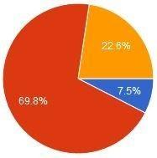

**Question**:- What do you prefer more?

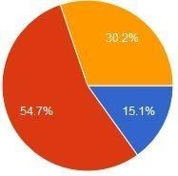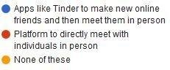

For detailed Survey Study [**Click Here**](https://docs.google.com/spreadsheets/d/13P4HfKCblOJzAJFlsnOkf541BwQy1zGsIG2IuRGAeuQ/edit?usp=sharing) **Product Objective:-** CatchUp aims that people will be able to connect with like-minded individuals & improve their social satisfaction through offline socialisation experiences.

# User Personas

|  |  |  |  |
| --- | --- | --- | --- |
| **Type of User →**  **Parameters ↓** | | **Attendee** | **Host** |
| 1. | General Information | Age - 23 Yrs  Occupation - IT Employee Place- Bangalore Relationship Status- Single Likes - Chilling on weekends | Age- 32 Years  Occupation - Startup Founder Place- Bangalore Relationship Status- Single Likes- Music & Storytelling |
| 2. | Behavior | -Extrovert & likes to make new friends  -Likes partying & spend time in common gatherings  -Do not prefer chatting with online friends | * Has been playing guitar from college days in band * Feels shy in participating music events in over-crowded cafes * Loves to share experiences |
| 3. | Concerns | Unable to find friends to accompany for a weekend outing for drinks. | Would like to find people with similar interest in music for jamming & relaxing |
| 4. | Needs | More options to socialize on weekends and feel relaxed | To form a local community of music lovers to do in-house concerts |

**User Journeys**

**User On-Boarding journey**

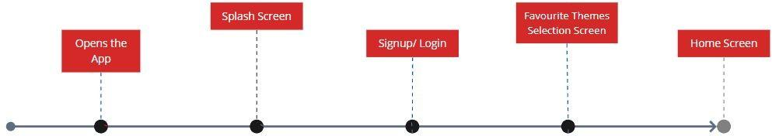

Clicking on App Icon Welcome screen Using Phone/Facebook For customised Home screen

**Sample Mockup :-** Mobile application Home Screen (After User onboarding)

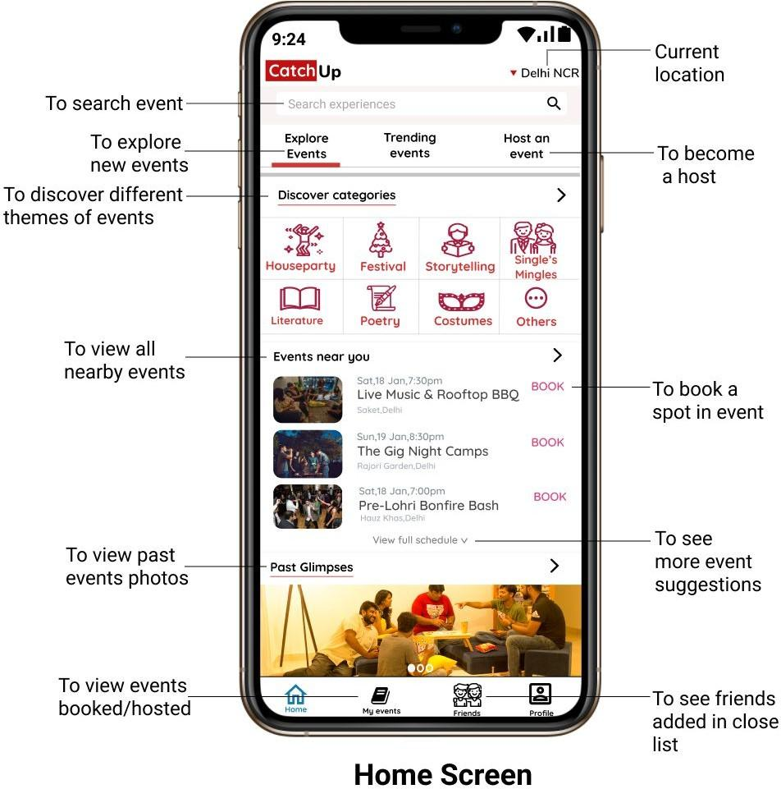

# Exploring / Joining Event journey

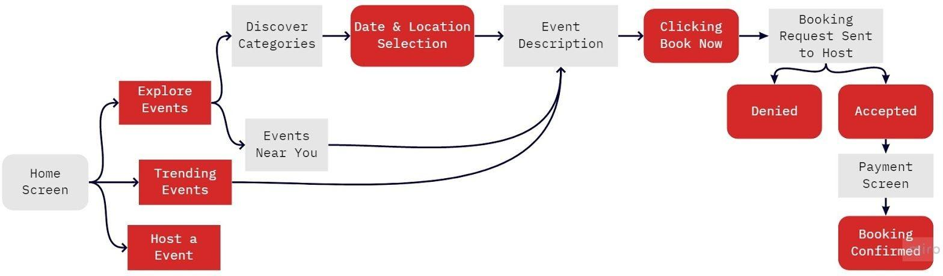

**Journey Description** (for the user to wishes to book a spot in the experience):-

**Step 1**. User will have 2 options to choose from either Explore events or Trending Events.

### Step 2.

Case 1: Explore Events selected:- User again have 2 choices to explore either discover

categories of events or nearby events.

Case 2: Trending Events selected:- User will see the trending events in the selected

location.

**Step 3**. User has to enter a date & location ( auto-selected and can be changed as well) to search for desired events.

**Step 4.** On clicking on any specific event from the search result, the event detailed description will be visible to the user.

**Step 5.** User will click on Book Now to make a request for booking a spot in the experience. (bookings for multiple people can also be made by adding the registered Catup users contact)

**Step 6**. The booking request will be sent to the Host for a response.

Case 1. Request Accepted:- A payment link will be sent to the user for making payment and conforming the spot.

Case 2. Request Denied:- Journey ends here and the user has to make another request.

**Step 7**. Booking confirmation notification & SMS will be sent to the user.

# Sample Mockups

**Event Display Screen** (left) :- After selecting theme, date & location of the event.

**Event Booking Screen** (right) :- After clicking on a specific event on the left screen.

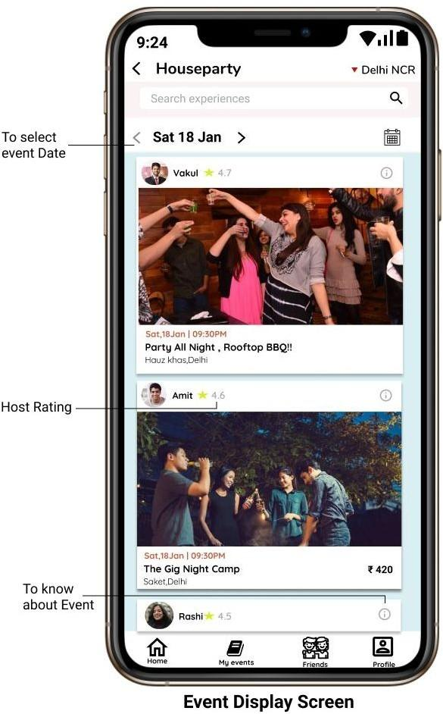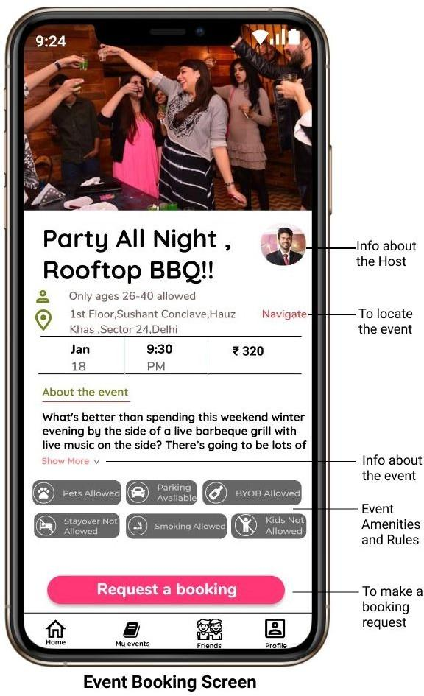

# Hosting Event Journey

**Journey Description** (for the user to wishes to host an event):-

**Step 1**. User has an option of Host an Event on the home screen.

**Step 2.** Previously hosted events will appear on the host screen along with an option to create a new event.

**Step 3.** Event description form will appear containing questions regarding event theme, title, pricing, guests preference, location and photos of the event place.

**Step 4.** User will submit the application which will be reviewed by company admin before making the event live.

**Step 5**. After the review and suggested changes, the event will be live for booking.

**Step 6**. User (Host) will receive the requests sent by the attendees and he will select the desired guests.

**Step 7**. The host will receive the information regarding the confirmed attendees (after they make the payment to the app)

**Step 8**. User will receive the expected payment amount within the 7 working days after the event.

# Sample Mockups

**Create Event Screen** (left) :- After clicking on Host an event on the Home Screen.

**Event Description Form Screen** (right) :- On clicking on the Create New Event (button) on the left screen.

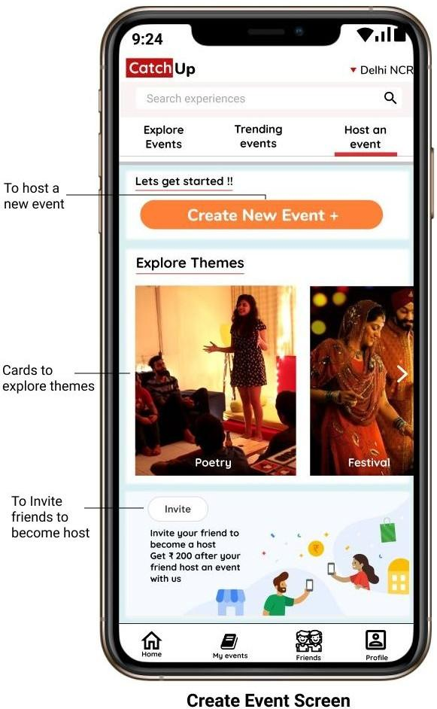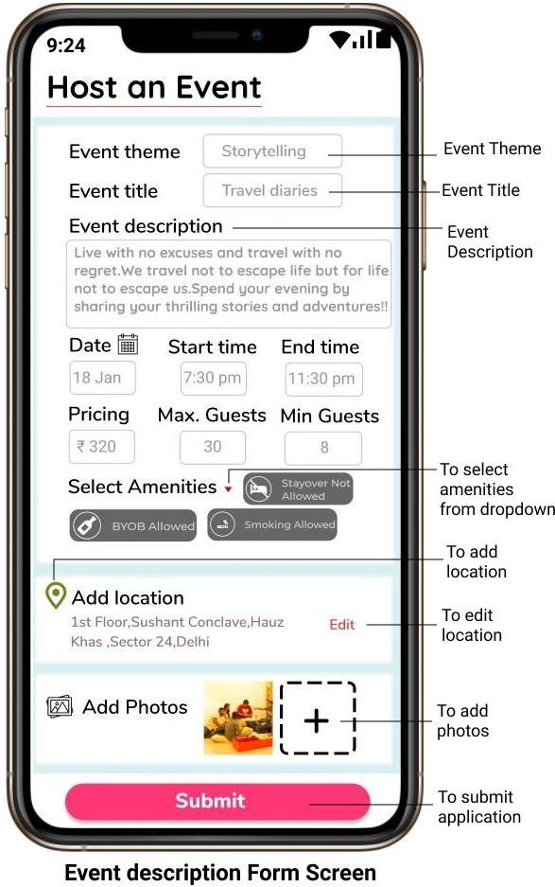

# After Experience/ Event Journey

**Journey Description** ( After the event has been over):-

### Step 1.

Case A) If the user is an attendee:- He has to rate the host out of 5 for future reference and leave any suggestions for the host so he can improve his services for the next time.

Case B) If the user is a Host:- He can report any attendee if he/she misbehaves or caused any problems during the event for the future references by the company.

### Step 2.

Attendee/ Host can send a friend request to anyone from the event for future connections after an event ends.

Case A) Request Accepted:- Both will get connected over the platform and can chat and plan further experiences together. Moreover, the information about an individual's next events will get shared with their friend list so that they can also join you over there for a better experience.

Case B) Request Denied:- User will not be able to connect to that particular individual over the app.

### Step 3.

Users have to rate the app out of 5 and provide suggestions(if any) to improve the user experience for further events & hence journey ends.

# Probable Problems faced by the user

### Case1. When user is an Attendee

**Problem 1**: Revisiting the app for payment procedure after booking request acceptance by the host.

Description : User has to again visit the app for the payment after the host has accepted his request to join the event. This may lead to frustration in some users due to discontinuous user journey.

Solution : Catchup e- wallet :- If user wants to skip post confirmation payment flow. He/ she can add a balance in the wallet. If the host accepts the user’s request, amount would get automatically deducted from the wallet and booking confirmation notification will be sent to the user.

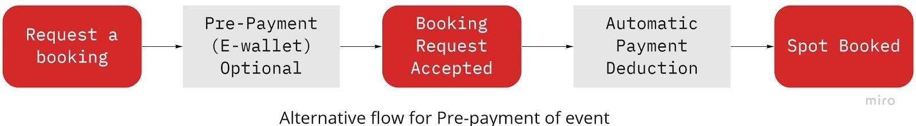

**Problem 2** : Security issues for the female attendees (while doing Pilot validation in IIT Roorkee)

Description : In cities like Delhi, women's safety is a primary issue. If a host uses some unfair means like toxicating one’s drink with sleeping drugs and make her to stay at his place with bad intentions.

Solution : To make our product gender sensitized, an additional safety feature for female attendees has been included which is:-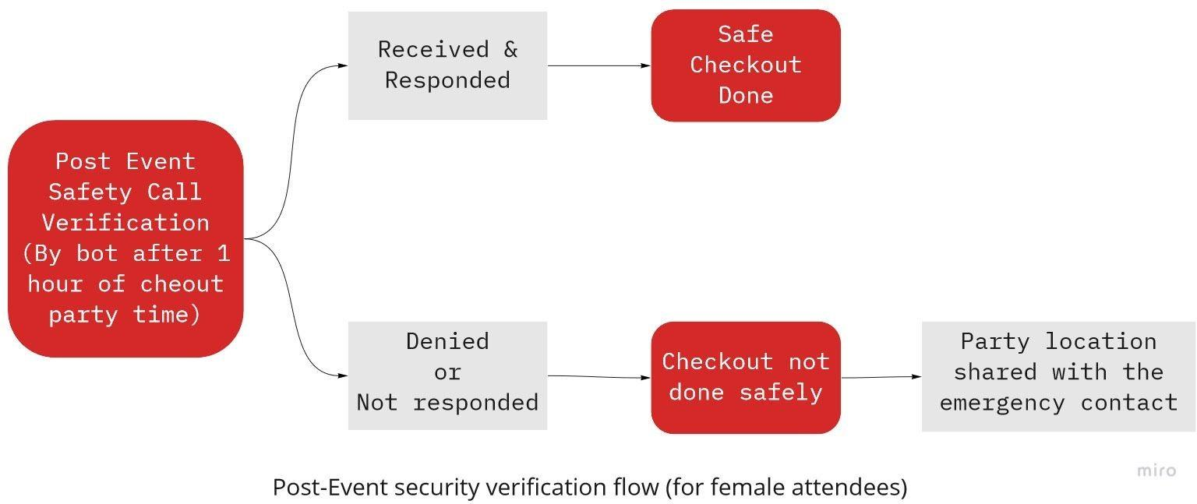

**Problem 3 :** Multiple times request rejection of any attendee.

Description : If an attendee faces multiple rejections by different hosts due to many possible reasons for e.g. gender, will lead to a bad experience as he/she won’t be able to attend events through the platform.

Solution : **CatchUp Assistant** :- This feature is not visible on app but comes to play when a user received more than 2 request rejections. It enables the user to improve his profile through AI based changes which will help him to get the requests accepted by hosts.

### Case 2. When user is a Host

**Problem** : Damages occured in the host’s property.

Description : Suppose if a table got damaged during the event unintentionally at the host’s house.

Solution : Our product also ensures the security to the host by providing him compensation for the relevant damaged of any item during the event. The compensation cycle has been described below in which the claimed item photos will be matched with the photos of event place submitted before the event (which is mandatory). The items which are not in the pre- submitted photos are not subjected for the claim.

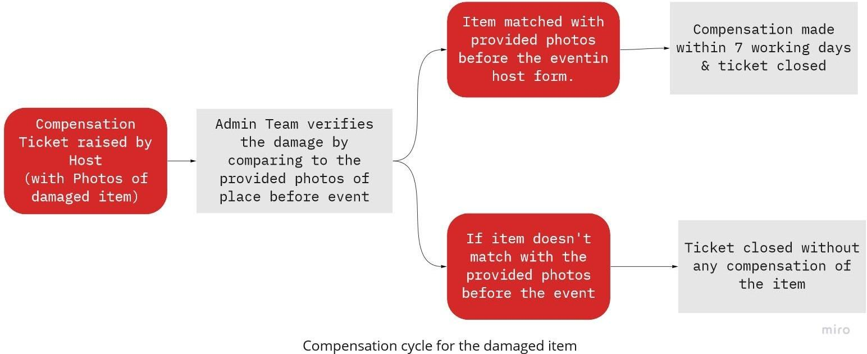

# Success Metrics

Measuring the growth of the Product (User Acquisition)

|  |  |  |
| --- | --- | --- |
| **Parameter** | **Metric** | **Relevance** |
| 1. Specific Occupancy Rate 2. Host growth rate 3. Confirmation Ratio | No. of confirmed bookings in an event  **---------------------------**  Threshold capacity of that event | The parameter will determine how the users behave accordingly with different types of events. This will help to figure out Trending & non trending events. & to promote low occupancy events as well. |
| % increase in no. of hosts on monthly basis | The parameter will be monitored to assess the become a host feature amongst the users. |
| No. of accepted attendees who made payment  **--------------------------**  Total no. accepted attendees | The parameter will be monitored to calculate a probable no. of attendees before the event which can be used to intimate the host about the probable number of guests who will be attending the event, in advance. |

### Measuring the health of the Product (User Retention)

|  |  |  |
| --- | --- | --- |
| **Parameter** | **Metric** | **Relevance** |
| 1. Retention Ratio | No. of active recurring users per month | The parameter will determine the retention of the feature amongst the users.  High retention ratio indicates positive health of product. |
| 2. Churn Rate | No. of users uninstalling the app  **--------------------------------**  Total no. of users of the app | This parameter will determine the user satisfaction from the product.  High churn rate will indicate negative health of the product. |
| 3. Existing customer revenue growth rate | % increase in the revenue generated by the app from existing customers. | This parameter will monitor the business generated through the app. |

**Probable Threats/ Failures to the Product**

**Security Issues:-** In Spite of safety & emergency measures, security issues still prevail in the markets like India for both attendees & hosts. Misbehaviour during or after event also leads to raising the security concerns.

**Tech-savvy crowd:-** In India, most of the crowd in tier 2 & 3 as well a part in tier 1 are less technology friendly which restrict the use of our product to a very limited segment. The age-group above 40, which wants to socialize may not be able to use our platform due to technical constraints.

**Social Issues:-** House events for socialization is a western concept originated from the European societies in the 19th century, so this idea might not be welcomed at the first come in Indian society. This was the reason why Airbnb failed in India.



# Created By:-

## Vakul Singh

## Pre-final Year student

IIT Roorkee

+91 8860210900

vsingh[@es.iitr.ac.in](mailto:msaini@bt.iitr.ac.in)